Project Report Template

# INTRODUCTION

## Overview : -

It demonstrates the interrelationship between the income statement and balance sheet and describes the risk and return trade-off underlying management decisions. Data are provided that compare the performance characteristics of small banks versus large banks and differentiate between high and low performers using assets. The banks having more assets are well running banks.

## Purpose : -

Banks acquire assets by making loans to businesses and individuals, investing in securities, and holding reserves with the central bank.  However, banks also have a responsibility to manage their assets effectively and minimize risk to maintain the safety and soundness of the banking to generate income and profits for the bank while also providing liquidity and security for depositors' funds.Banks also have a responsibility to manage their assets effectively and minimize risk to maintain the safety and soundness of the banking system.

# Problem definition & Design thinking

## Empathy Map :-

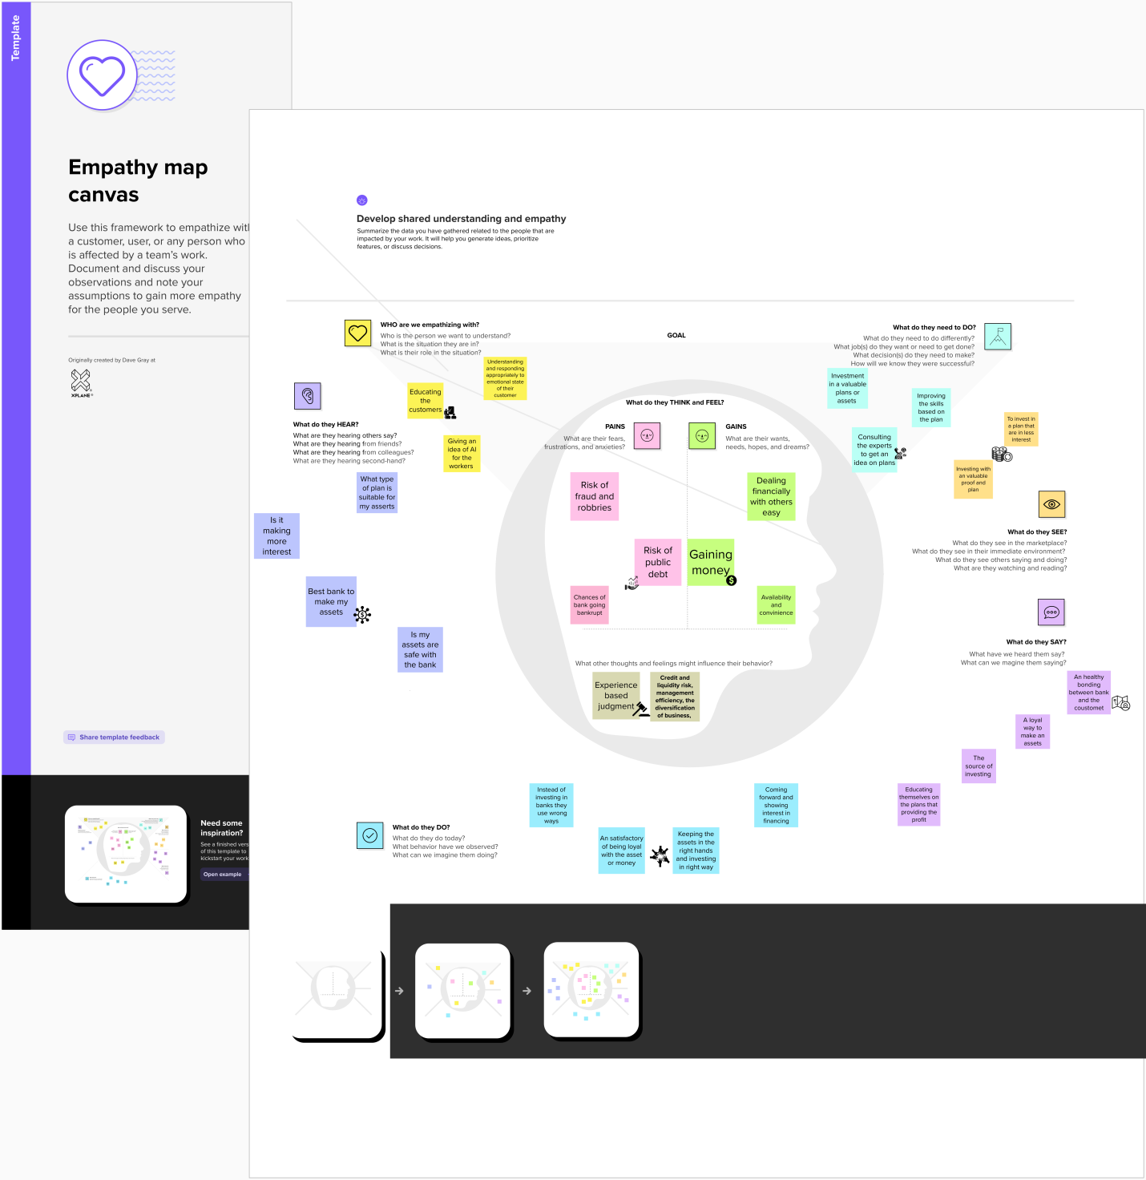

## Ideation & Brainstroming map :-

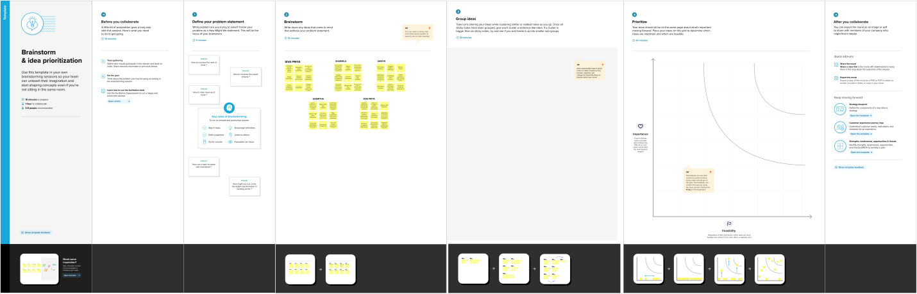

# Result

Banks facilitate economic growth and development by providing credit to businesses and individuals, which in turn helps to create jobs and support consumption. By effectively managing their assets, banks can help to promote financial stability and contribute to the overall health of the financial system. However, banks must also be mindful of the risks associated with their assets, such as credit risk, market risk, and liquidity risk, and take appropriate measures to manage these risks effectively.

# Advantages & Disadvantages

## Advantages :-

* Income Generation: Bank assets such as loans, mortgages, and s form of interest payments, dividends, and capital gains.
* Liquidity: Bank assets, such as cash and government securities, are highly liquid and can be easily converted into cash to meet short-term obligations.
* Diversification: Banks can diversify their asset portfolios to reduce risk by investing in a range of asset classes, such as stocks, bonds, and real estate.
* Collateral: Bank assets, such as real estate or other property, can be used as collateral for loans and other financial products, providing security for the lender.
* Regulatory Compliance: Banks are required to maintain a certain level of assets to comply with regulatory requirements, such as capital adequacy ratios, which help ensure the stability and solvency of the banking system.

## Disadvantages :-

* Credit Risk: Bank assets, such as loans and securities, carry the risk of default or non-payment by borrowers or issuers, which can lead to losses for the bank.
* Interest Rate Risk: Bank assets, such as fixed-rate loans and securities, are subject to interest rate risk, which can affect the bank's profitability and solvency.
* Market Risk: Bank assets, such as stocks and bonds, are subject to market risk, which can result in losses due to fluctuations in the financial markets.
* Regulatory Compliance: While regulatory requirements help ensure the stability of the banking system, they can also limit a bank's ability to invest in certain types of assets or activities.
* Operational Risk: Banks may face operational risks, such as fraud or errors, which can result in losses or reputational damage.

# Applications

* When banks have more assets, they are typically able to offer more services and have a greater capacity to lend money to individuals and businesses.
* Increased lending capacity: Banks with more assets are able to lend more money to individuals and businesses. This can help stimulate economic growth and allow people to finance large purchases such as homes or cars.
* More diverse services: Banks with more assets can offer a wider range of services to their customers. This may include investment services, financial planning, or even insurance.
* Greater stability: Banks with larger asset bases are generally considered more stable and less likely to fail. This can be important for maintaining confidence in the banking system and ensuring the safety of customer deposits.
* More competitive rates: Banks with more assets may be able to offer more competitive interest rates on loans and deposits. This can be especially beneficial for consumers looking to borrow or save money.
* Increased regulatory scrutiny: Banks with larger asset bases are often subject to more regulatory scrutiny from government agencies. This can help ensure that they are operating in a safe and sound manner, but it can also increase compliance costs for the bank.

# Conclusion

In conclusion, banks can improve their assets by embracing new technologies, expanding into new markets, developing new financial products, strengthening their risk management practices, and forming strategic partnerships with other financial institutions. By leveraging their resources and expertise, banks can adapt to changing market conditions and continue to grow their assets over time.

However, banks should also be mindful of the risks associated with asset growth, such as increased regulatory scrutiny, liquidity challenges, and the potential for market disruptions. Therefore, banks must strike a balance between asset growth and risk management to ensure long-term stability and sustainability.

Overall, the future of banks and their assets will be shaped by a range of economic, technological, and social factors. By remaining flexible and innovative, banks can continue to play a vital role in the financial system and contribute to sustainable economic growth.

# Future Scope

* Expansion into new markets: Banks with more assets can expand into new markets, both domestically and internationally. By acquiring or partnering with other financial institutions, banks can gain access to new customers and increase their lending and investment portfolios.
* Offering more personalized services: Banks with more assets can leverage their data analytics capabilities to offer more personalized services to customers. By analyzing customer data, banks can identify new product opportunities and tailor their offerings to meet the specific needs of different customer segments.
* Investing in technology: Banks with more assets can invest in new technologies to improve their operations and enhance their customer experience. For example, they can invest in artificial intelligence and machine learning to improve their risk management practices, or in blockchain technology to increase the security and efficiency of their payment process.
* Increasing financial inclusion: Banks with more assets can use their resources to increase financial inclusion, particularly in underbanked or underserved communities. By offering innovative products and services that meet the needs of these customers, banks can expand their customer base and improve financial inclusion.
* Supporting sustainable finance: Banks with more assets can use their influence to support sustainable finance initiatives. This could involve offering green investment products, financing renewable energy projects, or adopting sustainable lending practices that promote environmental and social sustainability.

## Overall, the future scope of banks having more assets is likely to be shaped by a range of economic, technological, and social factors. By leveraging their resources and expertise, banks can play a key role in shaping the future of the financial services industry and promoting sustainable economic growth.

# Appendix

## Source Code :-

<!DOCTYPE html>

<html lang="en">

<head>

  <meta charset="utf-8">

  <meta content="width=device-width, initial-scale=1.0" name="viewport">

  <title>Financial Analytics</title>

  <meta content="" name="description">

  <meta content="" name="keywords">

  <!-- Favicons -->

  <link href="assets/img/favicon.png" rel="icon">

  <link href="assets/img/apple-touch-icon.png" rel="apple-touch-icon">

  <!-- Google Fonts -->

  <link rel="preconnect" href="https://fonts.googleapis.com">

  <link rel="preconnect" href="https://fonts.gstatic.com" crossorigin>

  <link href="https://fonts.googleapis.com/css2?family=Open+Sans:ital,wght@0,300;0,400;0,500;0,600;0,700;1,300;1,400;1,600;1,700&family=Montserrat:ital,wght@0,300;0,400;0,500;0,600;0,700;1,300;1,400;1,500;1,600;1,700&family=Raleway:ital,wght@0,300;0,400;0,500;0,600;0,700;1,300;1,400;1,500;1,600;1,700&display=swap" rel="stylesheet">

  <!-- Vendor CSS Files -->

  <link href="assets/vendor/bootstrap/css/bootstrap.min.css" rel="stylesheet">

  <link href="assets/vendor/bootstrap-icons/bootstrap-icons.css" rel="stylesheet">

  <link href="assets/vendor/aos/aos.css" rel="stylesheet">

  <link href="assets/vendor/glightbox/css/glightbox.min.css" rel="stylesheet">

  <link href="assets/vendor/swiper/swiper-bundle.min.css" rel="stylesheet">

  <!-- Template Main CSS File -->

  <link href="assets/css/main.css" rel="stylesheet">

  <!-- =======================================================

  * Template Name: Impact - v1.1.1

  * Template URL: https://bootstrapmade.com/impact-bootstrap-business-website-template/

  * Author: BootstrapMade.com

  * License: https://bootstrapmade.com/license/

  ======================================================== -->

</head>

<body>

  <!-- ======= Header ======= -->

  <section id="topbar" class="topbar d-flex align-items-center">

    <div class="container d-flex justify-content-center justify-content-md-between">

      <div class="contact-info d-flex align-items-center">

        <i class="bi bi-envelope d-flex align-items-center"><a href="mailto:contact@example.com">financialanalysis@gmail.com</a></i>

        <i class="bi bi-phone d-flex align-items-center ms-4"><span>+999999999</span></i>

      </div>

      <div class="social-links d-none d-md-flex align-items-center">

        <a href="#" class="twitter"><i class="bi bi-twitter"></i></a>

        <a href="#" class="facebook"><i class="bi bi-facebook"></i></a>

        <a href="#" class="instagram"><i class="bi bi-instagram"></i></a>

        <a href="#" class="linkedin"><i class="bi bi-linkedin"></i></i></a>

      </div>

    </div>

  </section><!-- End Top Bar -->

  <header id="header" class="header d-flex align-items-center">

    <div class="container-fluid container-xl d-flex align-items-center justify-content-between">

      <a href="index.html" class="logo d-flex align-items-center">

        <!-- Uncomment the line below if you also wish to use an image logo -->

        <!-- <img src="assets/img/logo.png" alt=""> -->

        <h1>Financial Analysis<span>.</span></h1>

      </a>

      <nav id="navbar" class="navbar">

        <ul>

          <li><a href="#hero">Home</a></li>

          <li><a href="#about">About</a></li>

          <li><a href="#portfolio">Dashboard</a></li>

          <li><a href="#team">Story</a></li>

          <li><a href="#contact">Contact</a></li>

        </ul>

      </nav><!-- .navbar -->

      <i class="mobile-nav-toggle mobile-nav-show bi bi-list"></i>

      <i class="mobile-nav-toggle mobile-nav-hide d-none bi bi-x"></i>

    </div>

  </header><!-- End Header -->

  <!-- End Header -->

  <!-- ======= Hero Section ======= -->

  <section id="hero" class="hero">

    <div class="container position-relative">

      <div class="row gy-5" data-aos="fade-in">

        <div class="col-lg-6 order-2 order-lg-1 d-flex flex-column justify-content-center text-center text-lg-start">

          <h2>Welcome to <span>Financial Analytics</span></h2>

          <p>A widely used approach to analyzing top banks using assets and ranks.</p>

          <div class="d-flex justify-content-center justify-content-lg-start">

            <a href="#about" class="btn-get-started">Get Started</a>

            <a href="https://www.youtube.com/watch?v=fTTGALaRZoc" class="glightbox btn-watch-video d-flex align-items-center"><i class="bi bi-play-circle"></i><span>Watch Video</span></a>

          </div>

        </div>

        <div class="col-lg-6 order-1 order-lg-2">

          <img src="assets/img/200w.gif" class="img-fluid" alt="" data-aos="zoom-out" data-aos-delay="100">

        </div>

      </div>

    </div>

    <div class="icon-boxes position-relative">

      <div class="container position-relative">

        <div class="row gy-4 mt-5">

          <div class="col-xl-3 col-md-6" data-aos="fade-up" data-aos-delay="100">

            <div class="icon-box">

              <div class="icon"><i class="bi bi-card-text"></i></div>

              <h4 class="title"><a href="" class="stretched-link">Statiscal analysis</a></h4>

            </div>

          </div>

          <!--End Icon Box -->

          <div class="col-xl-3 col-md-6" data-aos="fade-up" data-aos-delay="200">

            <div class="icon-box">

              <div class="icon"><i class="bi bi-bar-chart"></i></div>

              <h4 class="title"><a href="" class="stretched-link">Data Visualization</a></h4>

            </div>

          </div>

          <!--End Icon Box -->

          <div class="col-xl-3 col-md-6" data-aos="fade-up" data-aos-delay="300">

            <div class="icon-box">

              <div class="icon"><i class="bi bi-laptop"></i></div>

              <h4 class="title"><a href="" class="stretched-link">Machine Learning</a></h4>

            </div>

          </div>

          <!--End Icon Box -->

          <div class="col-xl-3 col-md-6" data-aos="fade-up" data-aos-delay="500">

            <div class="icon-box">

              <div class="icon"><i class="bi bi-cpu"></i></div>

              <h4 class="title"><a href="" class="stretched-link">Artificial Intelligence</a></h4>

            </div>

          </div>

          <!--End Icon Box -->

        </div>

      </div>

    </div>

    </div>

  </section>

  <!-- End Hero Section -->

  <main id="main">

    <!-- ======= About Us Section ======= -->

    <section id="about" class="about">

      <div class="container" data-aos="fade-up">

        <div class="section-header">

          <h2>About Project</h2>

          <p> A Comprehensive Analysis of Financial Performance Insights from a Leading Banks </p>

        </div>

        <div class="row gy-4">

          <div class="col-lg-6">

            <h3>Insight bank assets through various Visualizations</h3>

            <img src="assets/img/about.jpg" class="img-fluid rounded-4 mb-4" alt="">

          </div>

          <div class="col-lg-6">

            <div class="content ps-0 ps-lg-5">

              <p class="fst-italic">

                We provide solutions to develop banks finance & assets.

              </p>

              <ul>

                <li><i class="bi bi-check-circle-fill"></i> Extracting data of various country banks using finanacial assets.</li>

                <li><i class="bi bi-check-circle-fill"></i> Building Data models using Tableau.</li>

                <li><i class="bi bi-check-circle-fill"></i> Developing the predictive models.</li>

              </ul>

              <div class="position-relative mt-4">

                <img src="assets/img/about-2.jpg" class="img-fluid rounded-4" alt="">

                <a href="https://www.youtube.com/watch?v=LXb3EKWsInQ" class="glightbox play-btn"></a>

              </div>

            </div>

          </div>

        </div>

      </div>

    </section><!-- End About Us Section -->

    <!-- ======= Stats Counter Section ======= -->

    <section id="stats-counter" class="stats-counter">

      <div class="container" data-aos="fade-up">

        <div class="row gy-4 align-items-center">

          <div class="col-lg-6">

            <img src="assets/img/stats-img.svg" alt="" class="img-fluid">

          </div>

          <div class="col-lg-6">

            <div class="stats-item d-flex align-items-center">

              <span data-purecounter-start="0" data-purecounter-end="1000000" data-purecounter-duration="1" class="purecounter"></span>

              <p><strong>Students</strong> has Succesfully trained</p>

            </div><!-- End Stats Item -->

            <div class="stats-item d-flex align-items-center">

              <span data-purecounter-start="0" data-purecounter-end="300" data-purecounter-duration="1" class="purecounter"></span>

              <p><strong>Projects</strong> has been developed</p>

            </div><!-- End Stats Item -->

            <div class="stats-item d-flex align-items-center">

              <span data-purecounter-start="0" data-purecounter-end="10000" data-purecounter-duration="1" class="purecounter"></span>

              <p><strong>Hours Of Support</strong> has been delivered</p>

            </div><!-- End Stats Item -->

          </div>

        </div>

      </div>

    </section><!-- End Stats Counter Section -->

    <!-- ======= Call To Action Section ======= -->

    <section id="call-to-action" class="call-to-action">

      <div class="container text-center" data-aos="zoom-out">

        <a href="https://www.youtube.com/watch?v=To2nuBRP7fE" class="glightbox play-btn"></a>

        <h3>Call To Action</h3>

        <a class="cta-btn" href="#">Call To Action</a>

      </div>

    </section><!-- End Call To Action Section -->

    <!-- ======= Portfolio Section ======= -->

    <section id="portfolio" class="portfolio sections-bg">

      <div class="container" data-aos="fade-up">

        <div class="section-header">

          <h2>Dashboard</h2>

        </div>

<<div class='tableauPlaceholder' id='viz1681365778224' style='position: relative'><noscript><a href='#'><img alt='Financial Analysis Of Banks ' src='https:&#47;&#47;public.tableau.com&#47;static&#47;images&#47;Fi&#47;Financialanalysis_16813656999330&#47;Dashboard1&#47;1_rss.png' style='border: none' /></a></noscript><object class='tableauViz'  style='display:none;'><param name='host_url' value='https%3A%2F%2Fpublic.tableau.com%2F' /> <param name='embed_code_version' value='3' /> <param name='site_root' value='' /><param name='name' value='Financialanalysis_16813656999330&#47;Dashboard1' /><param name='tabs' value='no' /><param name='toolbar' value='yes' /><param name='static_image' value='https:&#47;&#47;public.tableau.com&#47;static&#47;images&#47;Fi&#47;Financialanalysis_16813656999330&#47;Dashboard1&#47;1.png' /> <param name='animate_transition' value='yes' /><param name='display_static_image' value='yes' /><param name='display_spinner' value='yes' /><param name='display_overlay' value='yes' /><param name='display_count' value='yes' /><param name='language' value='en-US' /><param name='filter' value='publish=yes' /></object></div>                <script type='text/javascript'>                    var divElement = document.getElementById('viz1681365778224');                    var vizElement = divElement.getElementsByTagName('object')[0];                    if ( divElement.offsetWidth > 800 ) { vizElement.style.width='100%';vizElement.style.height=(divElement.offsetWidth*0.75)+'px';} else if ( divElement.offsetWidth > 500 ) { vizElement.style.width='100%';vizElement.style.height=(divElement.offsetWidth*0.75)+'px';} else { vizElement.style.width='100%';vizElement.style.height='977px';}                     var scriptElement = document.createElement('script');                    scriptElement.src = 'https://public.tableau.com/javascripts/api/viz_v1.js';                    vizElement.parentNode.insertBefore(scriptElement, vizElement);                </script>

      </div>

    </section><!-- End Portfolio Section -->

    <!-- ======= Our Team Section ======= -->

    <section id="team" class="team">

      <div class="container" data-aos="fade-up">

        <div class="section-header">

          <h2>Story Board</h2>

          <div class='tableauPlaceholder' id='viz1681365770217' style='position: relative'><noscript><a href='#'><img alt='Story Board ' src='https:&#47;&#47;public.tableau.com&#47;static&#47;images&#47;Fi&#47;Financialanalysisstory&#47;Story1&#47;1_rss.png' style='border: none' /></a></noscript><object class='tableauViz'  style='display:none;'><param name='host_url' value='https%3A%2F%2Fpublic.tableau.com%2F' /> <param name='embed_code_version' value='3' /> <param name='site_root' value='' /><param name='name' value='Financialanalysisstory&#47;Story1' /><param name='tabs' value='no' /><param name='toolbar' value='yes' /><param name='static_image' value='https:&#47;&#47;public.tableau.com&#47;static&#47;images&#47;Fi&#47;Financialanalysisstory&#47;Story1&#47;1.png' /> <param name='animate_transition' value='yes' /><param name='display_static_image' value='yes' /><param name='display_spinner' value='yes' /><param name='display_overlay' value='yes' /><param name='display_count' value='yes' /><param name='language' value='en-US' /><param name='filter' value='publish=yes' /></object></div>                <script type='text/javascript'>                    var divElement = document.getElementById('viz1681365770217');                    var vizElement = divElement.getElementsByTagName('object')[0];                    vizElement.style.width='100%';vizElement.style.height=(divElement.offsetWidth*0.75)+'px';                    var scriptElement = document.createElement('script');                    scriptElement.src = 'https://public.tableau.com/javascripts/api/viz_v1.js';                    vizElement.parentNode.insertBefore(scriptElement, vizElement);                </script>

    <!-- ======= Contact Section ======= -->

    <section id="contact" class="contact">

      <div class="container" data-aos="fade-up">

        <div class="section-header">

          <h2>Contact</h2>

          <p></p>

        </div>

        <div class="row gx-lg-0 gy-4">

          <div class="col-lg-4">

            <div class="info-container d-flex flex-column align-items-center justify-content-center">

              <div class="info-item d-flex">

                <i class="bi bi-geo-alt flex-shrink-0"></i>

                <div>

                  <h4>Location:</h4>

                  <p>Hosur</p>

                </div>

              </div><!-- End Info Item -->

              <div class="info-item d-flex">

                <i class="bi bi-envelope flex-shrink-0"></i>

                <div>

                  <h4>Email:</h4>

                  <p>financialnalytics@gmail.com</p>

                </div>

              </div><!-- End Info Item -->

              <div class="info-item d-flex">

                <i class="bi bi-phone flex-shrink-0"></i>

                <div>

                  <h4>Call:</h4>

                  <p>+1 5589 55488 55</p>

                </div>

              </div><!-- End Info Item -->

              <div class="info-item d-flex">

                <i class="bi bi-clock flex-shrink-0"></i>

                <div>

                  <h4>Open Hours:</h4>

                  <p>Mon-Sat: 11AM - 23PM</p>

                </div>

              </div><!-- End Info Item -->

            </div>

          </div>

          <div class="col-lg-8">

            <form action="forms/contact.php" method="post" role="form" class="php-email-form">

              <div class="row">

                <div class="col-md-6 form-group">

                  <input type="text" name="name" class="form-control" id="name" placeholder="Your Name" required>

                </div>

                <div class="col-md-6 form-group mt-3 mt-md-0">

                  <input type="email" class="form-control" name="email" id="email" placeholder="Your Email" required>

                </div>

              </div>

              <div class="form-group mt-3">

                <input type="text" class="form-control" name="subject" id="subject" placeholder="Subject" required>

              </div>

              <div class="form-group mt-3">

                <textarea class="form-control" name="message" rows="7" placeholder="Message" required></textarea>

              </div>

              <div class="my-3">

                <div class="loading">Loading</div>

                <div class="error-message"></div>

                <div class="sent-message">Your message has been sent. Thank you!</div>

              </div>

              <div class="text-center"><button type="submit">Send Message</button></div>

            </form>

          </div><!-- End Contact Form -->

        </div>

      </div>

    </section><!-- End Contact Section -->

  </main><!-- End #main -->

  <!-- ======= Footer ======= -->

  <footer id="footer" class="footer">

    <div class="container">

      <div class="row gy-4">

        <div class="col-lg-5 col-md-12 footer-info">

          <a href="index.html" class="logo d-flex align-items-center">

            <span>Financial Analytics</span>

          </a>

          <p>We provide solutions to your business.</p>

          <div class="social-links d-flex mt-4">

            <a href="#" class="twitter"><i class="bi bi-twitter"></i></a>

            <a href="#" class="facebook"><i class="bi bi-facebook"></i></a>

            <a href="#" class="instagram"><i class="bi bi-instagram"></i></a>

            <a href="#" class="linkedin"><i class="bi bi-linkedin"></i></a>

          </div>

        </div>

        <div class="col-lg-2 col-6 footer-links">

          <h4>Useful Links</h4>

          <ul>

            <li><a href="#">Home</a></li>

            <li><a href="#">About us</a></li>

            <li><a href="#">Services</a></li>

            <li><a href="#">Terms of service</a></li>

            <li><a href="#">Privacy policy</a></li>

          </ul>

        </div>

        <div class="col-lg-2 col-6 footer-links">

          <h4>Our Services</h4>

          <ul>

            <li><a href="#">Data Science</a></li>

            <li><a href="#">Artificial Intelligence</a></li>

            <li><a href="#">Business Intelligence</a></li>

            <li><a href="#">Data Analytics</a></li>

            <li><a href="#">Cloud Application Development</a></li>

          </ul>

        </div>

        <div class="col-lg-3 col-md-12 footer-contact text-center text-md-start">

          <h4>Contact Us</h4>

          <p>

            Hosur<br>

            Hosur, Tamilnadu - 635109<br>

            India <br><br>

            <strong>Phone:</strong> +1 5589 55488 55<br>

            <strong>Email:</strong> financialanalysis@example.com<br>

          </p>

        </div>

      </div>

    </div>

    <div class="container mt-4">

      <div class="copyright">

        &copy; Copyright <strong><span>Impact</span></strong>. All Rights Reserved

      </div>

      <div class="credits">

        <!-- All the links in the footer should remain intact. -->

        <!-- You can delete the links only if you purchased the pro version. -->

        <!-- Licensing information: https://bootstrapmade.com/license/ -->

        <!-- Purchase the pro version with working PHP/AJAX contact form: https://bootstrapmade.com/impact-bootstrap-business-website-template/ -->

        Designed by <a href="https://bootstrapmade.com/">BootstrapMade</a>

      </div>

    </div>

  </footer><!-- End Footer -->

  <!-- End Footer -->

  <a href="#" class="scroll-top d-flex align-items-center justify-content-center"><i class="bi bi-arrow-up-short"></i></a>

  <div id="preloader"></div>

  <!-- Vendor JS Files -->

  <script src="assets/vendor/bootstrap/js/bootstrap.bundle.min.js"></script>

  <script src="assets/vendor/aos/aos.js"></script>

  <script src="assets/vendor/glightbox/js/glightbox.min.js"></script>

  <script src="assets/vendor/purecounter/purecounter_vanilla.js"></script>

  <script src="assets/vendor/swiper/swiper-bundle.min.js"></script>

  <script src="assets/vendor/isotope-layout/isotope.pkgd.min.js"></script>

  <script src="assets/vendor/php-email-form/validate.js"></script>

  <!-- Template Main JS File -->

  <script src="assets/js/main.js"></script>

</body>

</html>